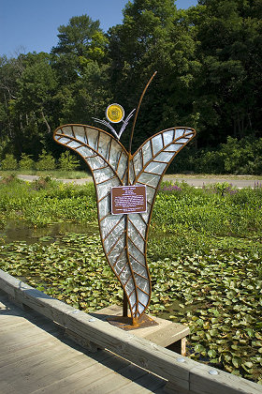
Who:
You are formally invited!

What:
Our Art & Wine Event

You are sure to enjoy:
Delicious appetizers,
wine tasting from
Contessa Wine Cellars,
local artists including
Joshua Andres Sculpture
…and
a brief narrative of our ministry.

When: Friday, October 17th, 2014.
Benton Harbor Art Hop runs from 6 -8:30pm. our formal event
starting at 8:30 prompt.

Where: The Oak Room at the Citadel
91 Hinkley St. Benton Harbor, MI 49022

Why: To celebrate 10 years of service in Berrien County &
To help overflow our well!

How: RSVP by October 13th,
Cost $35 per ticket; $60 per couple
…or purchase your ticket at the door.
Please remember seats are limited.

For more information,
give us a call at (269) 428-9355

